System Design

Jose Martinez

**Scope:**

The design described here is for the full implementation of the Emergency Resource Allocation Website.

**Definitions and acronyms:**

ERA Emergency Resource Allocation Website

GU Government User

CU Corporate User

CIV Civilian User

Corporation – a charitable company that is donating resources to aid in the rescue of disaster victims

Government – the government managed programs designed to aid in times of disasters, an example would be the Federal Emergency Management Agency (FEMA).

**Decomposition description**

The ERA consists of a general flow of data from the users to the database with the exception of the government level user, which has the permission to view the data entered into the database. There are two main tables, the regions table, and the resources table.

The resources table lists the amount of each resource provided by corporations and government programs. This table is useful in keeping track of what resources are abundant and which are lacking. Good for indicating what kind of help is most needed. This table gets a large amount of its data from records filled out by civilians. Information can be gathered more quickly by letting people report what they need and whether or not someone is deceased. With the abundance of cellphones today, during a disaster, having internet access or a working cellphone is sometimes more likely than having a home or food or water. Public libraries, schools, coffee shops and various other areas where people can get access to computers are other possible ways people will be able to report. This table shows which and where the most resources are needed.

The regions table lists which resources each region needs. Rather than have a whole table for each individual region, this table takes in all regions and each of their resources, what they need and how much of it.

Other tables in the database include the user table, civilian, corporation, and government tables. Initially it was expected that more tables would be needed, but the general design of the database and user interface allows successful implementation by combining attributes into certain tables. The separation of users into civilian, corporation, and government tables allows further development of the database in the future, as well as minimizing the number of empty columns that would result in having them all in the same table. For example government and corporate users are not required to list what region they are in, a field that would be largely empty if they were all in the same place. The user table holds all the common data from the three users so that general information such as name and email can be held in one place for quick access.

By breaking down the needs in a disaster into smaller tables rather than one giant one, we are able to update various aspects of the information without causing unnecessary redundancies and creating a large unreadable table. It makes the information more manageable and understandable.

**System Design Flowchart and walkthrough**

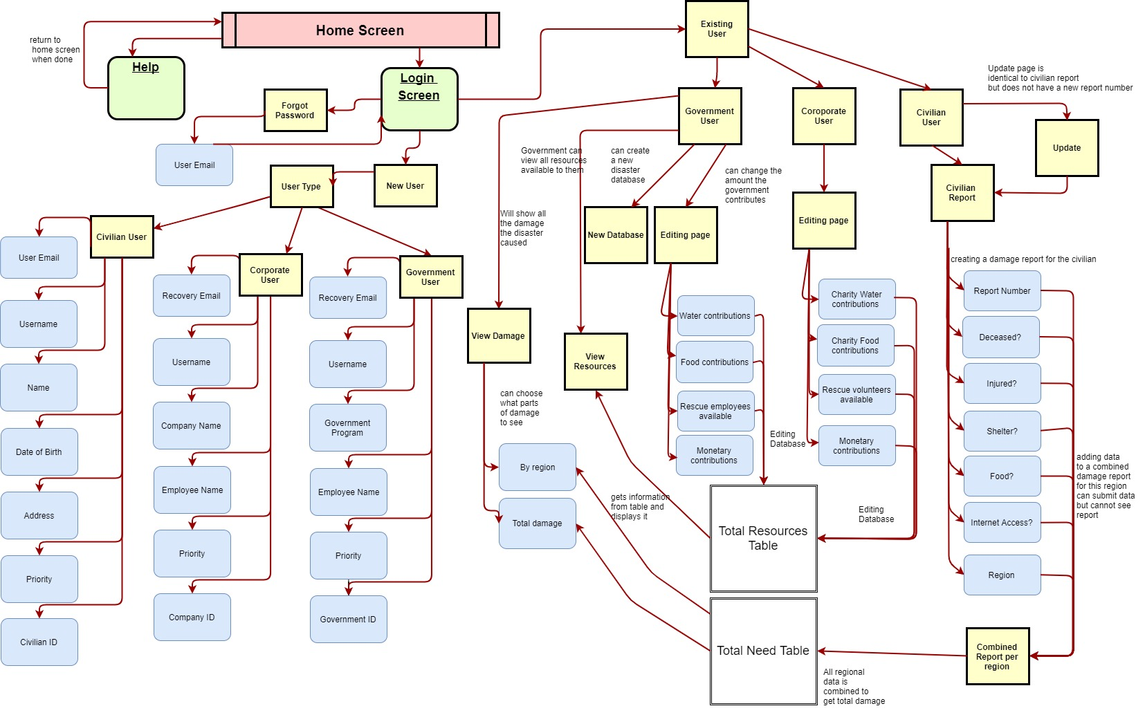

* User Authentication

The database will access the users table to and run a query searching for the username and password, if found the screen will move on to the corresponding screen. The next screen will be determined by the value in the “priv” column of the returned row from the query, here priv means privilege, what the specific user has access to. The three possible values for this attribute will be 2 for government, 1 for corporation, or 0 for civilian. These three values identify what type of user the person logging in is and what they will be able to do and what databases they will be able to alter.

* New User

Creating a new user will be determined by the user type the “priv” is an attribute in the users table that will identify the permissions of the user logging in, like which databases they can alter and what information they can see. Filling out the “sign up” fields in the login screen will allow the addition of new users. All users will have to sign up through the same sign up fields but depending on the user profile being created some fields will not be required.

* Existing users

Existing users will fill out the login fields and be sent to a webpage corresponding to their user privileges.

1. Government users

Government users are able to create new resource fields. The GU’s will be able to edit the resources table, having the ability to edit the total amount of help the government program will be able to provide for various resources. Government users can also choose to view the total resources listed so far in the resources table. In viewing the resources table, GU’s will be able to determine how much help has been given and determine how much more, if any, can be offered. Also they can see which resources are the lowest in supply. GU’s can also view data in the government table where they will essentially see who else is in their government program and they will be able to view information from the corporation table to see which organizations are helping and how many volunteers there are per organization. The government users will also be the users that are able to dispense resources to specific regions.

1. Corporate users

Corporate users have fewer permissions than GU’s. They cannot view the data in the government or corporate tables and cannot dispense resources. CU’s can only edit what they are choosing to contribute to the total resources table, they can add a new resource to donate and view the current state of the resources, such as how much there is in total and how much is needed. They cannot view how much of a given resource each region has. Government officials can always let charities know what is needed. They are also able to donate resources.

1. Civilian user

Civilian users have different permissions than GU’s and CU’s. When a civilian logs in they are essentially signing in to fill out a damage report specifying what it is they need. This information will essentially be a record in the regions table where the civilian reports can be organized by region. The damage report is a raw gathering of data from each individual who makes a claim. The regions table takes the raw information from the report and shows the needs of each individual region. In using this design, further implementations are possible where once a region has a new shelter available for those without a home, the users whose addresses are nearest the shelter could be notified via the provided email or phone number. This is an implementation I do not have enough experience to add but by maintaining the individuality of the data there is more versatility for development and use.

The ability for civilians to update their need will be determined by allowing the input of negative values. This will in turn affect the resources and regions tables, essentially notifying the government users that progress has been made in supplying the needs of the people this also helps the government not waste resources.

Layout explanation

Govt and corporate pages will have a Donate Resource button that will take them to the donate resources page. Govt and corporate pages will also have a View Resources button that will take them to the View Resources page. Govt and corporate pages will also have an Add Resource button that will take them to the Add Resource page.

Govt pages will also have a view region button, they will be taken to the View Regions page. And a view volunteers page where they can view all the volunteers they have (corporation people), name and username username will become company name and password will act as an id. Second part of the code will become the company name.

View Regions – will use a page like the show recipes page with a search box so that they can enter the region id that they want to see. It will list the regions from the regions table. View Regions will display the region id from region_Id, number of dead from numdead, number of houses destroyed from destrhome

View resources- uses a page like the view recipes page to view all the resources available. This page will also have a Donate Resources button and an Add Resources button. This page will be getting its information from the total_resources table.

Add Resource - Use a page like the add ingredients page to add a new resource with the unit and amount

Donate Resource – will have a login form kind of appearance that will list all the resources available with check boxes next to the resource. To the right of the resource will be empty input text boxes where the user can enter the amount they want to donate this value will be added to the amount column of the total_resources table. Unit from the total_resources table will not be able to be modified from here

Civilian pages will have a report_needs button that will take them to the Report Needs page the report

Report Need – can only be called from the Civilian page will be similar to the View Resources page, it will call the total resources table and display the available resources. It will also have an input box next to the resource name for the civilian user to enter how much of that resource they need. It differs from the view resources table in that it clicking the Request Resources button will add this value to the total need table. The Request Resources button from the Report Needs page will also add this value to the resources needed column of the regions table, if the resource is already listed (done with a findOneByResourcesNeeded(Resource) and do an if statement with a count to see if it already exists in the table, if found the amtResourceNeeded will be added otherwise it will add the resource to the table and the amtResourceNeeded the specific region will be specified by the regionID of the civilian user) it will be searched for in the table and the amount needed will be added to the amtResourceNeeded column of the regions table.

Home screen without user logged in:

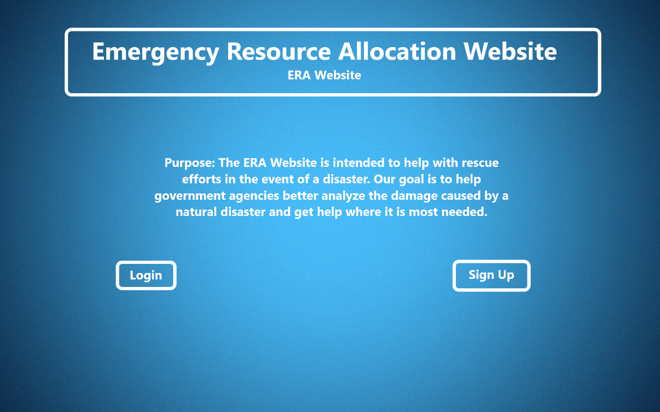

Clicking the link leads to the login/signup screen.

Basic Outline

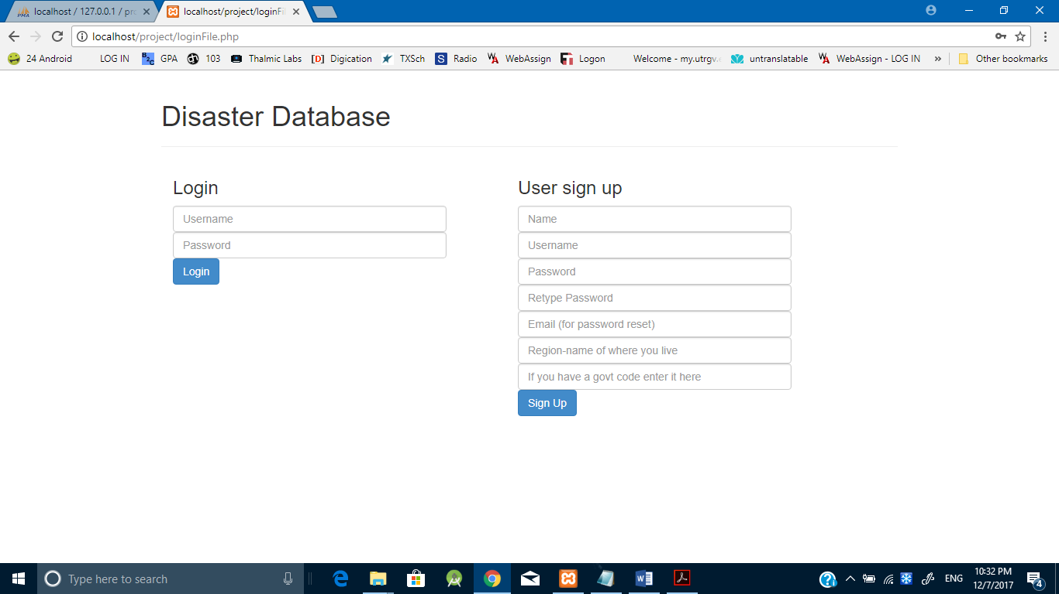

This is closer to what the final product will look like

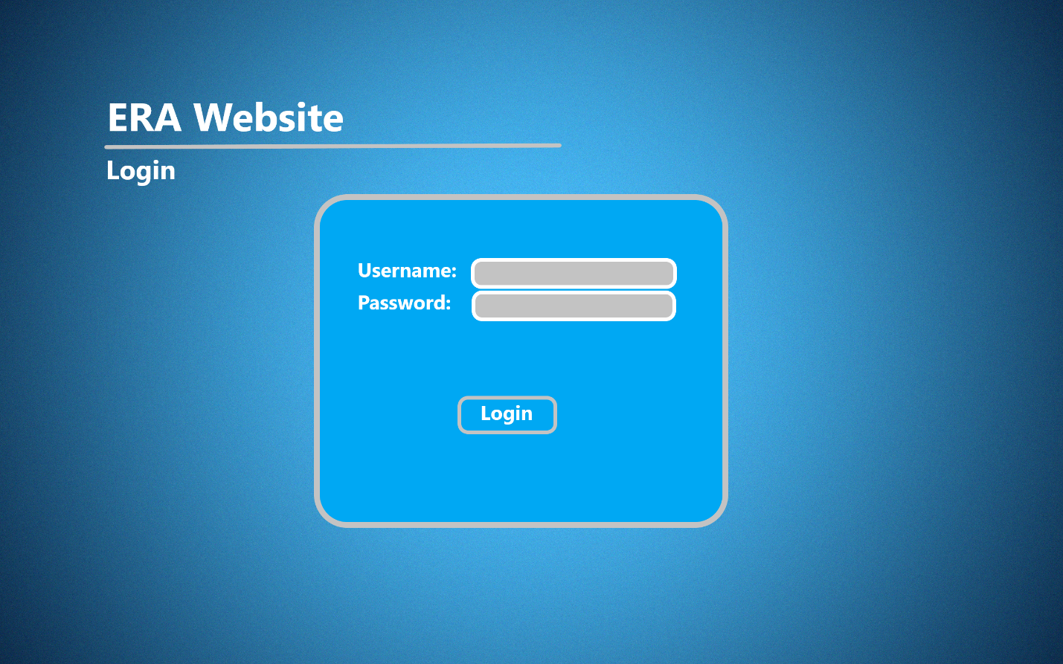

Signing in or signing up successfully leads back to the home screen where more options are now available for each of the three users.

Civilian user:

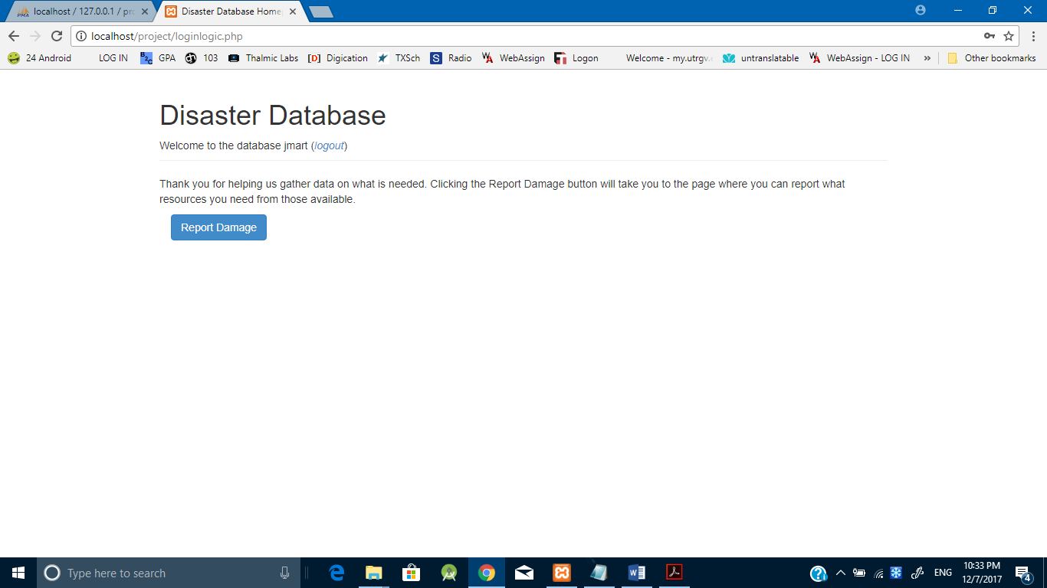

The Damage Report

Clicking the damage report button allows the civilian user to report how much of each resource they need. Here resources like “need electricity” and “home was destroyed” would be filled out by entering a 1 in the field to indicate that this person either needs electricity or had their home destroyed. These submissions can later be viewed by the government users when they are totaled up according to region.

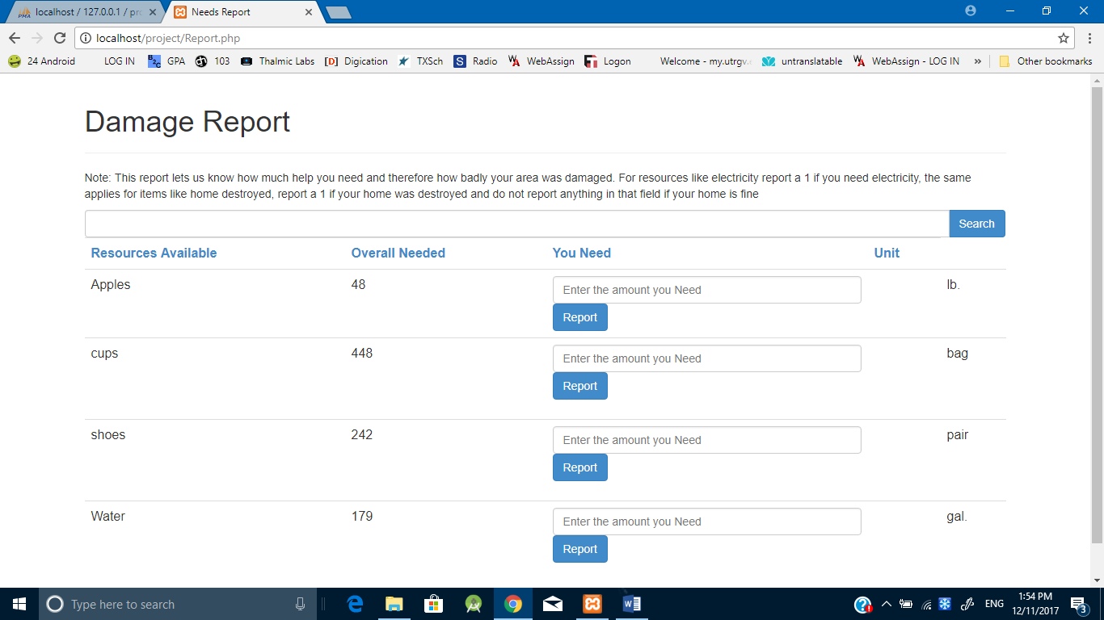

Corporate User

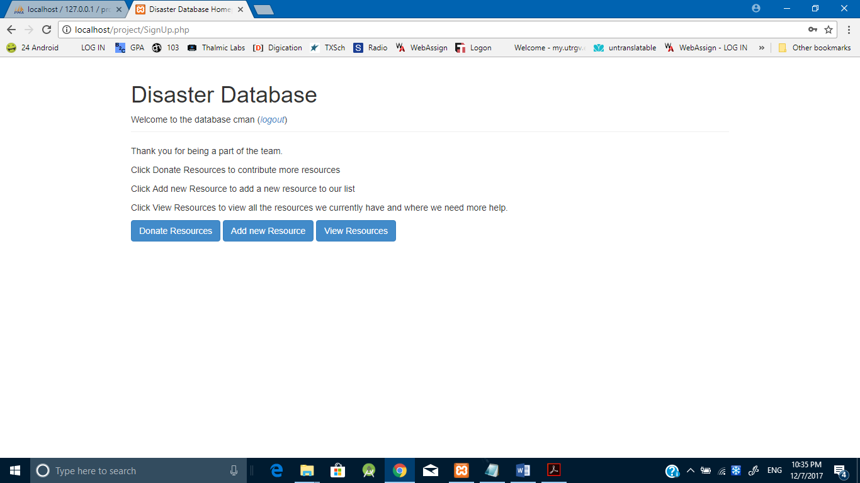

Government User

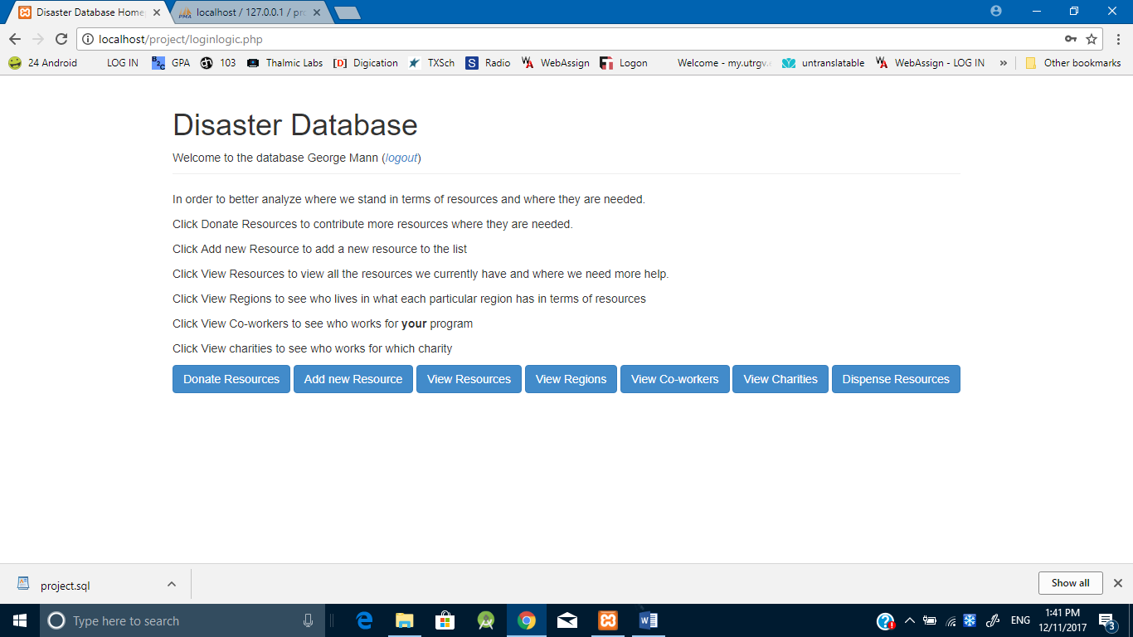

**Donate Resources**:

Will have a search bar in case a specific resource needs to be looked up. Will have the categories: Resource, Available, Need, and a textbox where the amount to be donated can be entered. Will have a donate that will add the amount to the available resources table.

**Add Resources**:

Will have a text box indicating what the name of the new resource will be and another text box that will indicate what form of measurement will be used for the resource; e.g. gallons of water, bottles of water, loaves of bread.

**View Regions**

Every region and its resources, what it lacks of each resource is presented on this page. The results can be narrowed down by using a search bar. Will have a category bar with the categories: Region Name, Resource, and Need.

**View Charities**

This page allows the government users to see all the charities that are helping in the disaster efforts. Results can also be filtered by searching for a particular company or username in a search bar. Just a list of the names of the charities

**Distribute Resources**

This page is only accessible to the government users. It allows the resources to be distributed amongst the regions. Regions and their needs are added by civilian users. Coroporate users are allowed to donate resources but cannot decide where they will be given they will not have access to this page. This page will list the Resources, how much is available and what regions need this resource along with how much each region needs of that resource, and a button to donate. Donating will update the resources database and the regions database.